TITLE OF ABSTRACT (Centered, 14 Points, Bold)

() A. LastName^{1,2}, B. LastName³ (IPB Supervisor), C. LastName⁴ (Home Univ. Supervisor)
¹Degree at IPB, Name of IPB School, Polytechnic Institute of Bragança, Portugal,
¹Degree at Home University, Name of Faculty, Home Institution, Home Country,
author1@company.net
³Department at IPB, Name of IPB School, Polytechnic Institute of Bragança, Portugal,
author2@company.net
⁴Department at Home University, Name of Faculty, Home Institution, Home Country,

author2@company.net

ABSTRACT
Place here your maximum 1 page abstract. Use 11 point Times New Roman (Normal Style). The abstract should summarize the context of your work in the Double Degree Course which will be presented at DD2018. It will be published in the book of abstracts.

Graphs, figures and tables must have a caption. Captions should be centered at the foot of the figure and typed in the same 11 point font used in the paper. References should be noted with square brackets [1] and figures with “fig.1”.

Please submit the abstract both in PDF format AND DOC format using the appropriate link at the wesite www.dd2018.ipb.pt by 30 June 2018.

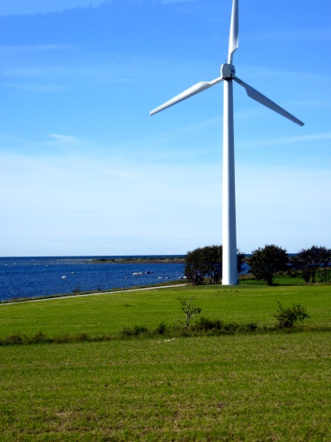

Figure 1: Example of a figure.

REFERENCES (Centered, 12 Points, Bold)
- S. Ivanell, J.N. Sørensen, “Wakes”, Journal of wakes, vol.2 (2004) pp. 695-706.

